38.43: 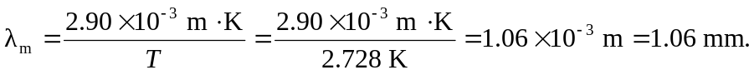 This is in the microwave part of the electromagnetic spectrum.

